Greenham 40th: Feminist Peace – opposing violence, militarism and war
Date and time: 31 August at 7.00 - 8.30 pm BST
The Greenham 40th anniversay Weaving the Web/inars online march continues with a conversation among activists from the Greenham Women's Peace Camp and Women in Black (WiB) on 'feminist peace' and the different ways we have opposed violence, military-industrial oppression and war in our countries and across borders.

With speakers from WiB in Haifa, Belgrade, London and Cape Town, we will explore the personal and political connections in feminist peace activism. What are the different ways of being visible and effective? How can we best centralise the needs and experiences of women and girls and take responsibility when living in aggressor nations? How do we perceive the links between patriarchal power, militarism, sexual violence, and rape as a war crime? How do we support each other and draw strength to keep going?

This webinar will take the form of a moderated conversation, including:

Rebecca Johnson, a feminist, peace and lesbian activist, carrying Greenham's feminist nonviolence into campaign strategies and songs for security, justice, sisterhood and disarmament, including with Women in Black since 1989.

Hannah Safran, a lesbian, peace and feminist activist with the Haifa Feminist Center and Women's Coalition for Peace, as well as opposing the Occupation with Women in Black since 1988, and through her research and teaching.

Lepa Mladjenovic, lesbian feminist anti-war activist, with Women in Black Belgrade from 1991, insisting on solidarity and collective care in difficult times.
Sian Jones, with other Greenham women, accidentally established Women's Aid to former Yugoslavia (WATFY), taking humanitarian aid and solidarity to anti-war/anti-nationalist groups supporting refugee women in Slovenia, Croatia, Bosnia-Herzegovina, Serbia and Kosovo during the 1990s wars.
Liz Khan, feminist peace activist with Hackney Greenham Women's Group in the 1980s and a co-founder of Women in Black London, which took the name in 1993 to support connect with WiB activists in Belgrade and Palestine-Israel.

Vanessa R Ludwig, African feminist, who continues to work towards the dream she had as a 'young revolutionary in the struggle' in the 1980s for a free Afrika and a peaceful, just world.

BACKGROUNDER

Women in Black (WiB) is an international movement of women who organise against violence against women, militarism and war, and work for peace with justice. WiB started in Jerusalem in January 1988, to support the Palestinian Intifada that had started a month before. Inspired by Black Sash in South Africa, the Madres de la Plaza de Mayo in Argentina, and the nonviolent opposition to nuclear weapons by Greenham women, Palestinian and Israeli women stood together, dressed in black, and holding up a black sign in the shape of a hand with 'Stop the Occupation' written in white. Soon women like Hannah were carrying out 'Women in Black' vigils in Haifa, as these nonviolent protests spread to other cities and then to Italy, Spain, the United States, Britain, Netherlands, India and beyond.

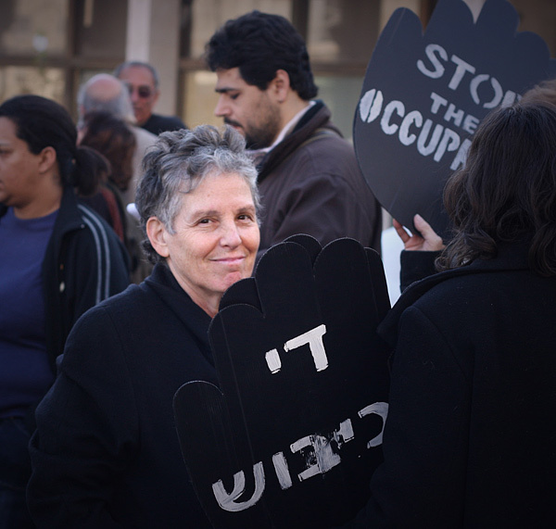

As war broke out in Yugoslavia in 1991, Women in Black from Italy (Donna en Nero) went to Zagreb and Belgrade to support feminist anti-war activists. Their support prompted Stasa, Lepa and other feminist activists living in Belgrade to set up WiB protests in the aggressor nation's capital. WiB Belgrade – Zene u Crnom – made Women in Black into a worldwide movement that not only opposed the war, but actively supported women who suffered most from the wars and violence. Politically and in many practical ways they supported survivors of rape and massacres, demanded that rape and sexual violence be recognised and prosecuted as war crimes.

Here, is what Lepa sent on Women in Black Belgrade:

here is the info on Women in Black Belgrade on the web site, that i have changed a bit to be more readable:
http://zeneucrnom.org/en/about

Women in Black Against War - Belgrade, is a feminist antimilitarist peace organisation, founded in October 1991 with the principal aim to oppose politics of war of the serbian regime, with weekly vigils standing in black and silence. Afterwards the group developed different activities.
Women in Black Belgrade have made visible nonviolent resistence to militarism, war, sexism, nationalism. In short, all aspects of violence towards and discrimination against women and all those people different ethnically, religiously, culturally, sexually, ideologically.
Women in Black Belgrade BUILD A WOMEN'S SOLIDARITY NETWORK, PEACE COALITION AND ALLIANCE against all patriarchal political control over women, all kinds of ethnic homogenization, independent of all state and ethnic borders and divisions. Our goal is to prevent conflicts, to resolve conflicts through dialogue, and above all instigating the active participation of women in the building of peace, in peaceful processes, and demilitarization. We began the International Network of Women in Black and organized ten meetings of that network under the title Women Solidarity Against War.

Women in Black Belgrade DEMAND A PERMANENT CONFRONTATION WITH THE PAST
accountability for war and war crimes, trying all those suspected of war crimes in the Hague tribunal. But also a confrontation with both the moral and political collective responsibility, through street actions, appeals, petitions, campaigns, attendance at commemorations, seminars, and conferences.
Women in Black Belgrade PRODUCE A WOMEN'S ALTERNATIVE HISTORY
by means of extensively publishing, works (ten books in the series "Women for Peace", many monographs, peace planners, calendars, and readers—altogether around fifty titles).
Women in Black Belgrade ORGANIZE PERMANENT PEACE EDUCATION
by means of seminars, workshops, courses about feminism, pacifism/antimilitarism, nonviolence, interethnic/intercultural solidarity, reproductive rights, and alter/globalization. Up to now we have held tens of international conferences, many seminars, hundreds of workshops, etc.
Women in Black Belgrade DEMANDED DEMILITARIZATION AND DISARMAMENT
by means of complete acknowledgement of all kinds of conscientious objection through peace education, campaigns, actions of civil disobedience, etc.

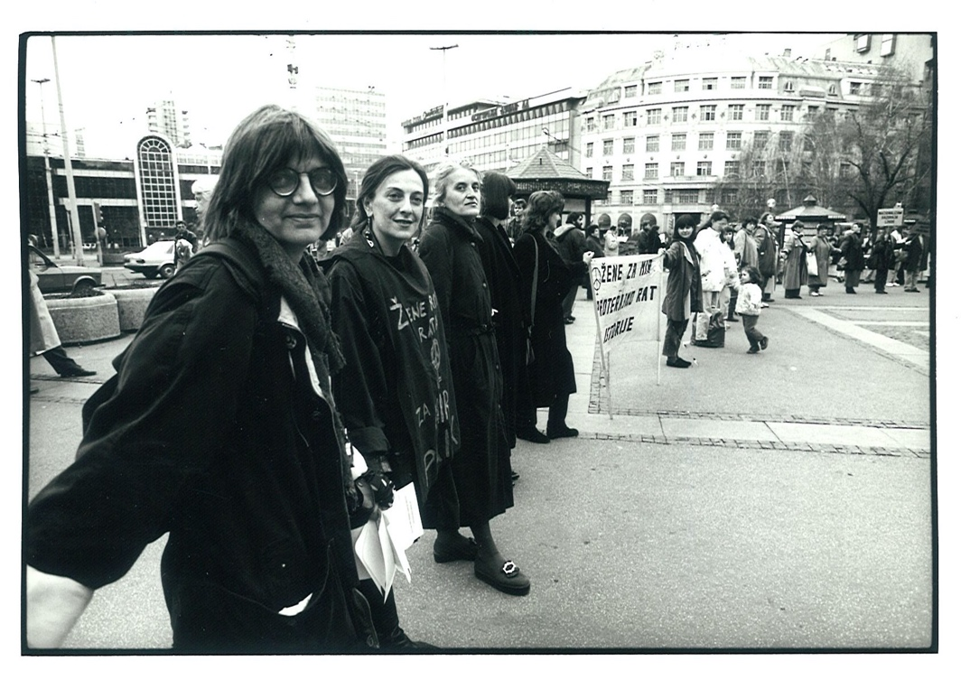
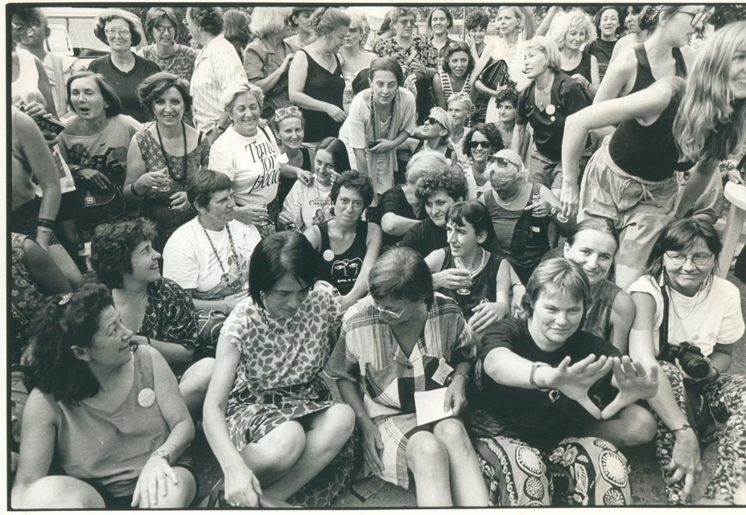

Personal as well as political stories weave together. Here you can see Rebecca (with symbolic womb-flame hands) and Lepa near the back, with WiB activists from Europe and various parts of ex-Yugoslavia with From a meeting at Greenham, to feminist aid convoys identified as 'Women for Peace' taking support to feminist anti-war activists and refugees in Slovenia, Croatia, Serbia and Bosnia-Herzegovina, and eventually Kosovo, with food, women's clothing and sanitary needs, medical and other practical aid.

Here is a description of Women's Aid to Former Yugoslavia (WATFY) in Sian's words:
Emerging from the Greenham network of empowered and able women, between 1992 and 1999 a group of anti-war, antimilitarist and feminist activists came together to provide support to the women's and anti-war movements and grass-roots projects supporting refugees during the war in former Yugoslavia. Knowing that our groups, our ideas, us, we, would be under such pressure were the roles reversed and that yes, we would welcome both political and practical solidarity from the outside world, we - with help from the wider British peace movement and some lovely hackers - reached out and made contact with our sisters.
In September 1992 Women's Aid to former Yugoslavia s first aid convoy, with nine women driving three trucks, set off for Slovenia, Croatia and Serbia where women's groups had asked us to bring humanitarian aid for the refugees they were working with. We returned with independent information on the war, including specific information on war crimes of sexual violence. We shared that information with our supporters and the grass roots media, and other women's organisations in joining the Women against War Crime coalition, and - sharing the concept of Women in Black - helped to grow WiB vigils and protests in towns and cities and direct action at military bases in the UK.
For the next seven years, WATFY women drove trucks of aid to Slovenia, Croatia, Serbia and Bosnia-Herzegovina, and eventually Kosovo, to provide food, medical and other practical aid requested by the anti-nationalist/anti war women's groups, specifically for the refugee and displaced women they worked with.
We tried to respond as respectfully and meaningfully as we could to the needs of a range of organisations including Women in Black in Belgrade, Centre for Women War Victims in Croatia, Medica Zenica in Bosnia-Herzegovina and Motrat Qirazi in Kosovo. Building on the initial support from Greenham women and other peace networks, over time the scope and audience for WATFY work broadened: in the UK a new knickers campaign resonated with the mainstream, garnering support from both the Women's Institute and readers of Cosmopolitan. WATFY also raised money to provide finance for specific medicines, local projects, including counselling training, and to fund and recruit local staff at the request of the women’s NGOs, and a separate charity - The Sock Project - was established to sell refugee women's knitted goods in the UK.
"Always disobedient", WATFY provided an alternative interpretation of what a humanitarian aid organisation looked like and how it behaved.
Photo: WATFY 'Women for Peace' truck full of aid going to feminist anti-war projects and refugee camps, 1990s.

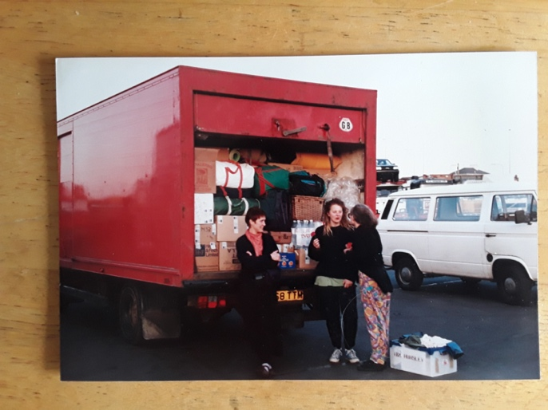
In March 1993, the first Women in Black action was initiated by Vimochana (Liberation) – a women's collective in Bangalore. They organised against the country being torn apart by the politics of 'communalism', fundamentalism and nationalism after the deliberate destruction of the Babri Masjid and the culture of peace coexistence that Babri Masjid symbolised.
After WiB Bangalore and Vimochana held the 2015 international Conference and World Court of Women Against Wars, For Peace alongside Women in Black's International Gathering, the next international gathering took place in Cape Town South Africa.
Here, Vanessa Roseline Ludwig takes up the story:
I am an Africanist feminist, having first been introduced to the philosophy of pan-Africanism while a teenager growing up in District 6 in Cape Town, South Africa. Feminism entered my realm of consciousness a few years later. These two philosophies have guided my actions since I was became a “young revolutionary in the struggle” in the late 1970’s.

Over the years I have worked as a trade unionist, educator, researcher, community developer, and ‘professional activist’ in various non-governmental organisations. Currently I am an independent consultant, focusing on Community Transformation and Sustainability, Organisation Transformation and Growth, and Feminist Research Methodologies.

I am a founding member of the Gei Heis Collective, a non-profit organisation that promotes the use of indigenous knowledge systems to transform society - politically, socially and economically. I am also a partner in Emthonjeni Holistic Wellness, a social enterprise that encourages us to see ourselves as the source of our wellness.

Over the past few years I have been working on how to live on less while contributing more to changing the world for the better. My grandmother taught us to “waste not, want not”. And she did not mean this in an individualistic manner, but that if we wasted, someone else was “wanting”.

When I am not engaged in activities that pay my taxes or getting my hands dirty in soil, I enjoy writing and illustrating stories for children and cooking healthy, organic food. I love experimenting with indigenous foods and flavours. Growing and cooking indigenous food for me is not only a celebration of our history and heritage, but about food sovereignty and ensuring a sustainable planet, because as Angela Y Davis said:
“The idea of freedom is inspiring. But what does it mean? If you are free in a political sense but have no food, what's that? The freedom to starve?”

WiB, Cape Town:
The XVII Gathering of WiB in South Africa under the theme “Displaced Lives” was a time for serious reflection of how the consequences of the philosophies of greed and domination (war, violence, persecution and ‘natural’ disasters) uproot our lives and make our existence tenuous. But it was also a celebration of our surviving, and at times thriving, against all odds. Womxn from across the globe, sometimes with very little in common and despite language barriers, came together to share our agonies and joys, our persistence in striving for a better world and our insistence on the right to be free from all forms of domination and exclusion. One of my favourite moments was the incredible healing and self-affirming dance with womxn from across the world in a session on healing. It reminded me of a young feminist comrade, during a march in Johannesburg in 2015 to demand justice for Fezekile ‘Khwezi’ Kuzwayo 10 years after Jacob Zuma had been found not guilty of raping her, saying that “we sing and dance to relieve ourselves of the pain and build our spirits for future battles”.
I loved it!

